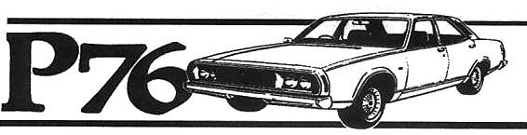
Hunter Valley P76 Owners Club
Associated with the NSW Country P76 club
October – January 2014 Newsletter
Editorial:
Hello all
A lot has changed in the last few months.
I travelled down to Mt Buller to compete in the Targa High Country tar Rally in the XR6 Falcon and had a great run. One competitor came over from Tasmania in his private helicopter and crashed it on Mt Buller with four on board.
In the first day of Targa the same fellow crashed his A9X Torana over the side as well
Our magazine will now be produced Quarterly as printing costs are eating into our resources and finding sufficient information to post is a problem.

Canberra 40th Anniversary of the P76 function:
While I did not attend I believe the occasion was a success. One of our members, John Judd, had his car on the cover of the Leyland Heritage magazine following the Canberra event, well done John.

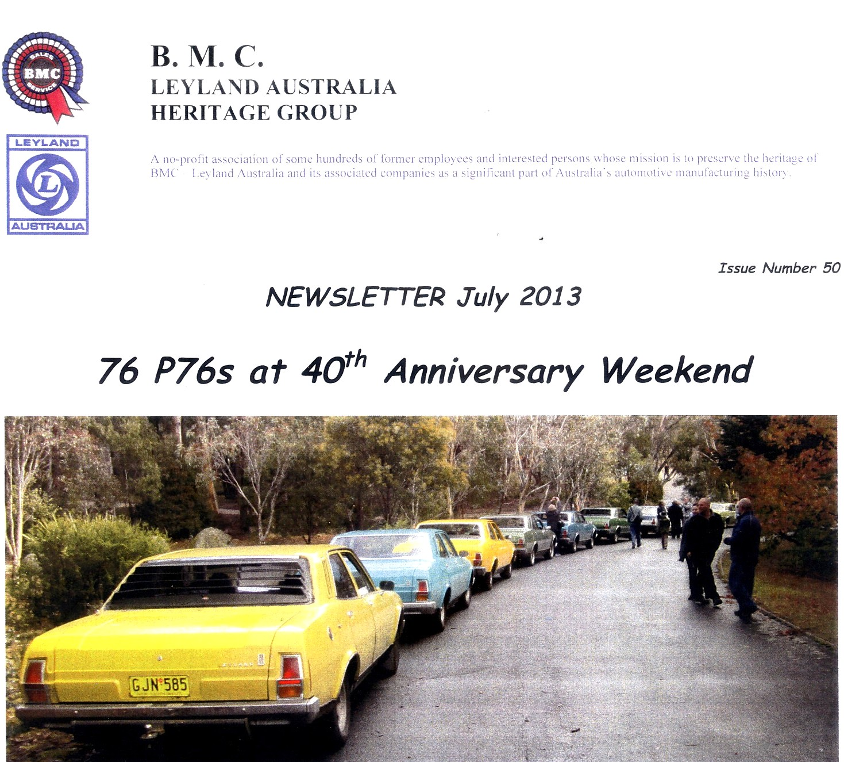

Our club is now hosting the 40th anniversary of the Targa Florio P76 at Heatherbrae on 26th & 27th July 2014. This date is about the time that the first Targa’s were produced.
Information is attached. Our contact is Johanna and note that her office times are 3-11pm Monday to Thursday

Note from Johanna:
Hal,
just a quick note about reservations for the Leyland Car Club.

I have set up a group booking in the name Leyland Car Club, so as Leyland lovers call up to reserve rooms they can use that name to ensure they get the group rate and will be included as part of your group.

Have a great Christmas and I’ll look forward to meeting with you again in the New Year.

Kind regards

Johanna Troop
Available 3-11pm Monday – Thursday
Midday – 10pm Sundays

Reservations
Conferences & Events
Marketing

Country Comfort, Motto Farm Motel
2285 Pacific Highway
HEATHERBRAE NSW 2324
Ph: 02 4987 1211
Fax: 02 4987 1214
Email: conference@newcastleairporthotel.com.au

I am currently sorting out the 200 + chrome P76 moulds that I have and two things have stood out
The RH & LH vertical windscreen moulds have the same part number HYC5674-5 but the parts book list them as RH HYC5674 & the LH as HYC5675
The vertical rear window moulds are two different lengths which may explain why I have had considerable trouble with the green car having one that is too short.
Most that I have are 407mm long and others are 426mm long

Please advise if attending
Any members with ideas on club functions. Get togethers Bar-B-Ques etc, please advise. A registration Form is attached

Our next Car Club run January 19th 2014:
This will be another combined car club run starting at Croudace Bay Parkt
Date: 19 January 2014.
Start: Croudace Bay Park. (Southern car park)
Finish: Allambee Park Valentine.
First car start time : 10AM .
Length : 140 Klms.
Duration: Approx. 2.5 Hrs.
Food will be available for purchase at the finish.

We have also been asked to display our cars at Bunnings Singleton on a date to be advised

New P76 Book:
My P76 book is undergoing a complete revision and hopefully will be released by the end of year 2014 with a lot of new information and photos. More information on this later.

The club in general:
Photos from last club run to We had a very good rollup on the run to Allworth where had lunch in Waters Park.
Some stayed on with David to view some of his fleet.

Information sought:
A booklet was produced for the 40th P76 function in Canberra. I wrote an article as requested called “Rallying the P76 40 years on”, can anyone advise if this article was in the P76 40th booklet.
All the people I have spoken to that went to Canberra are unable to answer thisquestion???
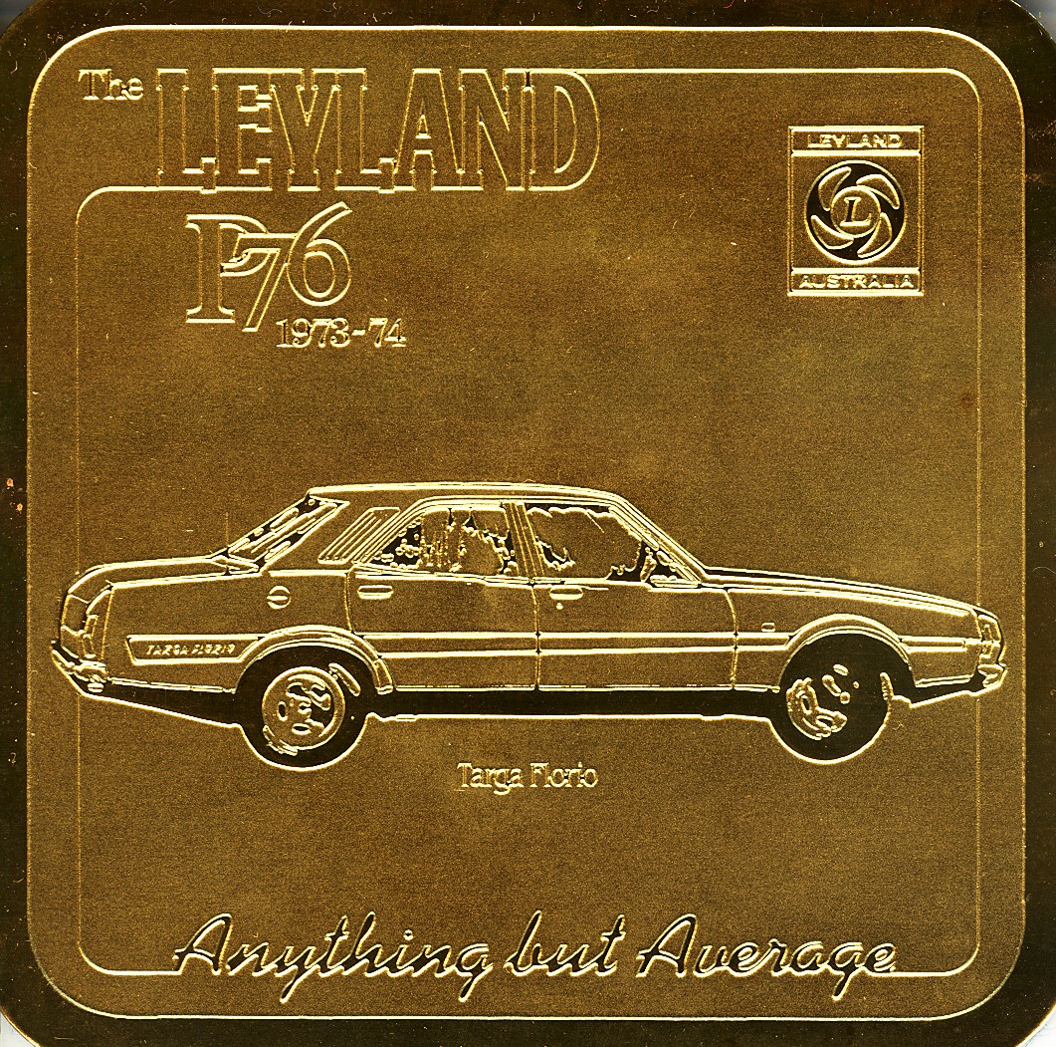

REGISTRATION FORM
Date: 26th & 27th July 2014
Venue: Motto Farm Country Comfort Motel
Registration Fee: $30.00 per vehicle includes Sunday Bar B Que can be paid on arrival or included with the registration form and returned to: Targa 40th, 18 Irving St Beresfield 2322 or to either
halmoloney@gmail.com or craigp76@hotmail.com
Saturday night Dinner Fee: $25.00 per person, this can be booked to your room or paid on the night.
A small fee payable at the museum door will be required to enter “Lost in the 50’s” car museum. Fee to be advised.

Persons attending: 1............................... 2........................................
3................................4........................................
Vehicle details:.....................................................................................
All Motel Reservations are to be made to Johanna as listed below and mention “Leyland Function”
Johanna Troop
Available 3-11pm Monday – Thursday
Midday – 10pm Sundays

Reservations
Conferences & Events
Marketing

Country Comfort, Motto Farm Motel
2285 Pacific Highway
HEATHERBRAE NSW 2324
Ph: 02 4987 1211
Fax: 02 4987 1214
Email: conference@newcastleairporthotel.com.au

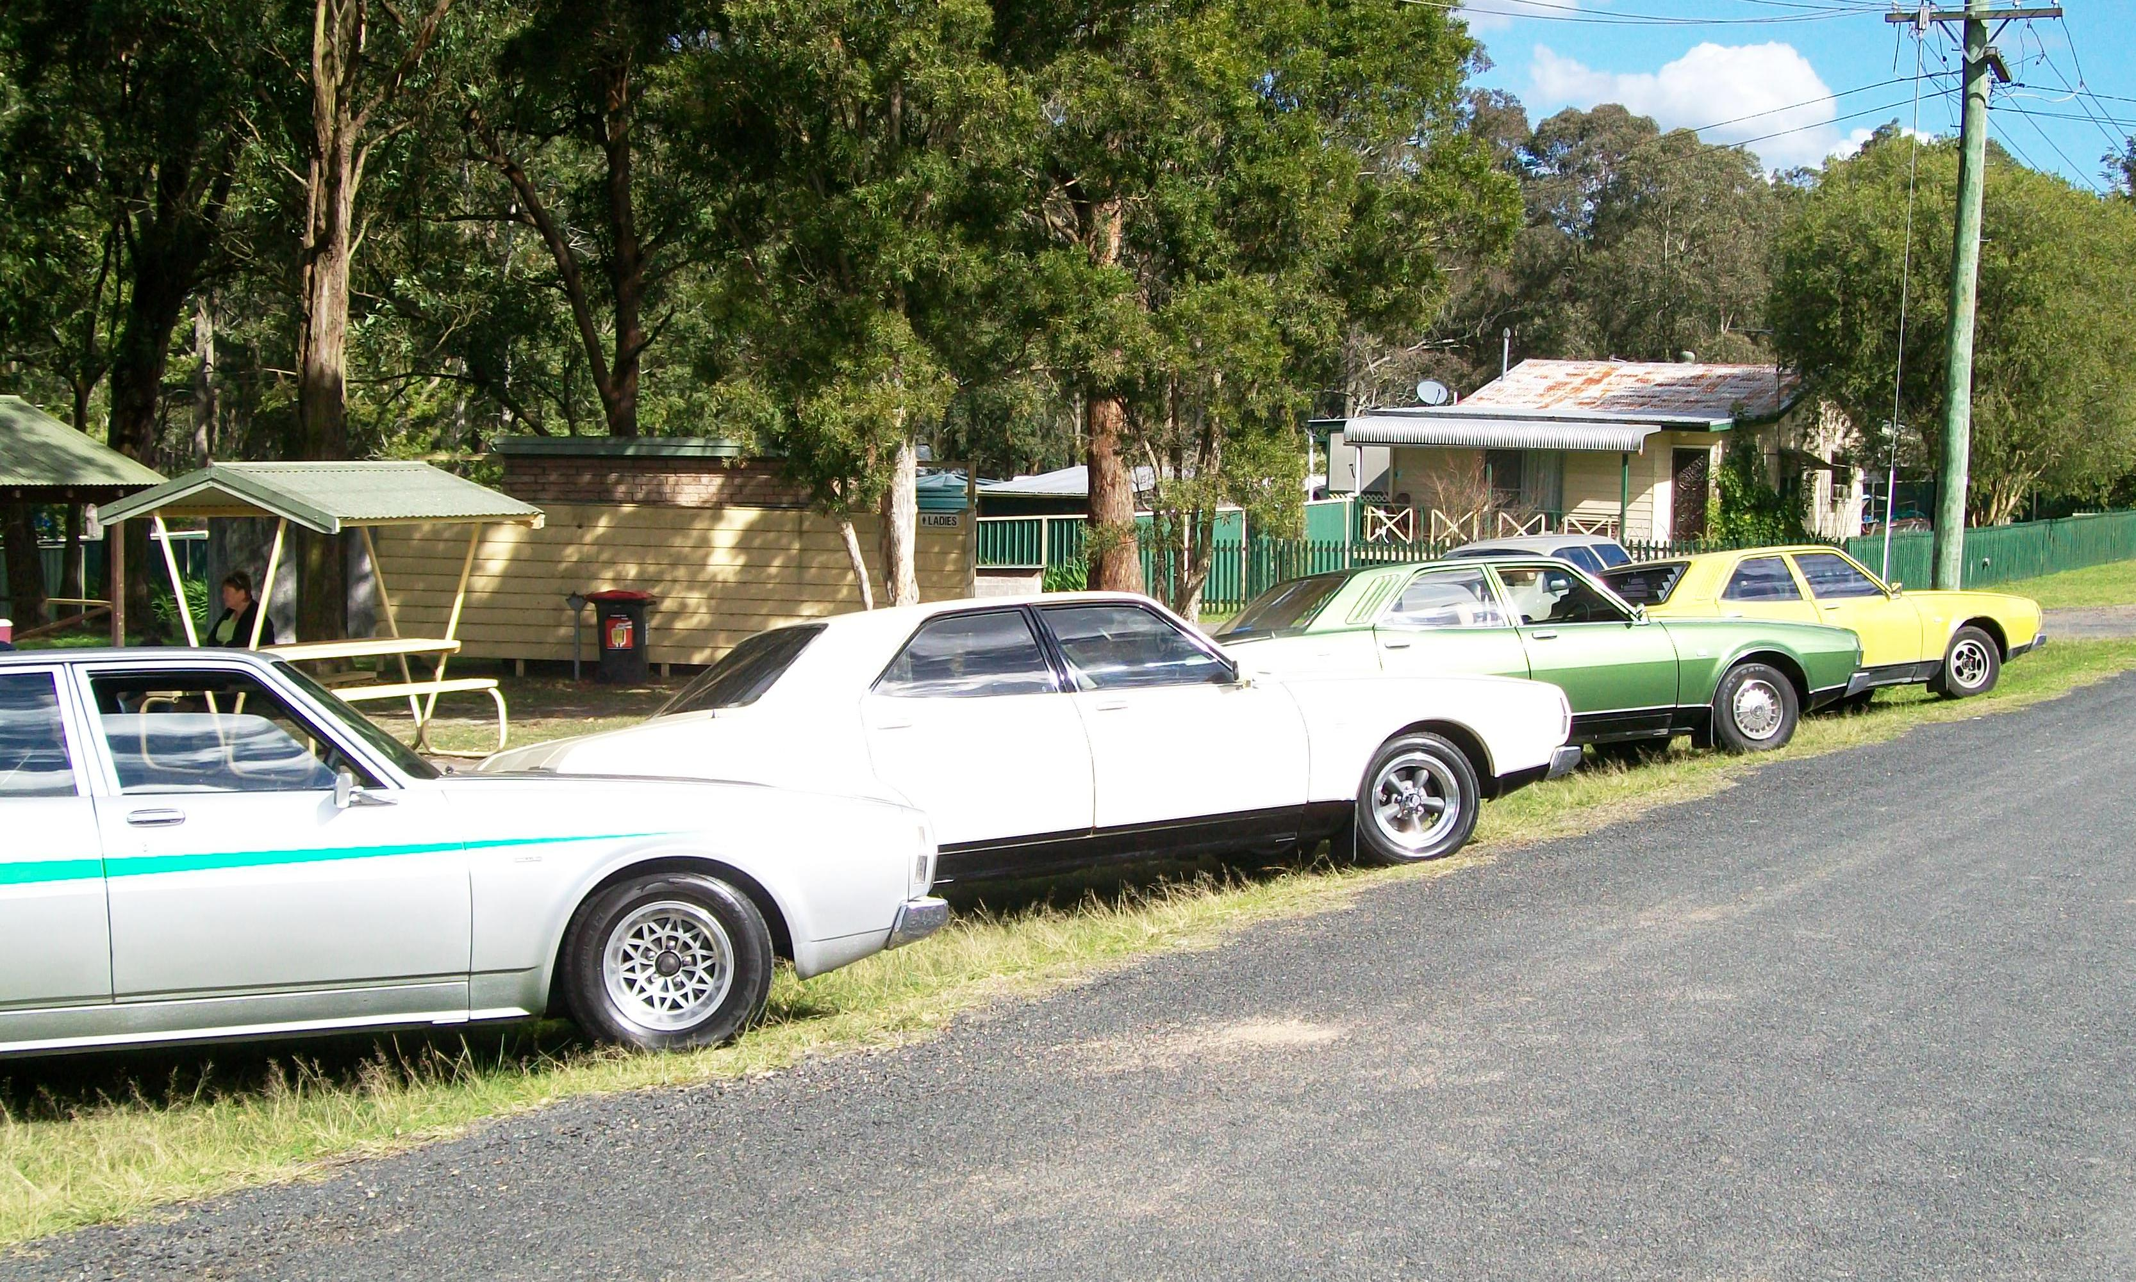
Club cars at Allworth

We have been invited to a club run with the Historic Rally club on the 19th of January starting from Croudace Bay Park at 10.00am The run will be 140km and finish at Valentine.
Sorry about the short notice on this run.
Our member Gordon Murray is now out of hospital and improving. We hope to see Gordon and Kay at a Club run soon

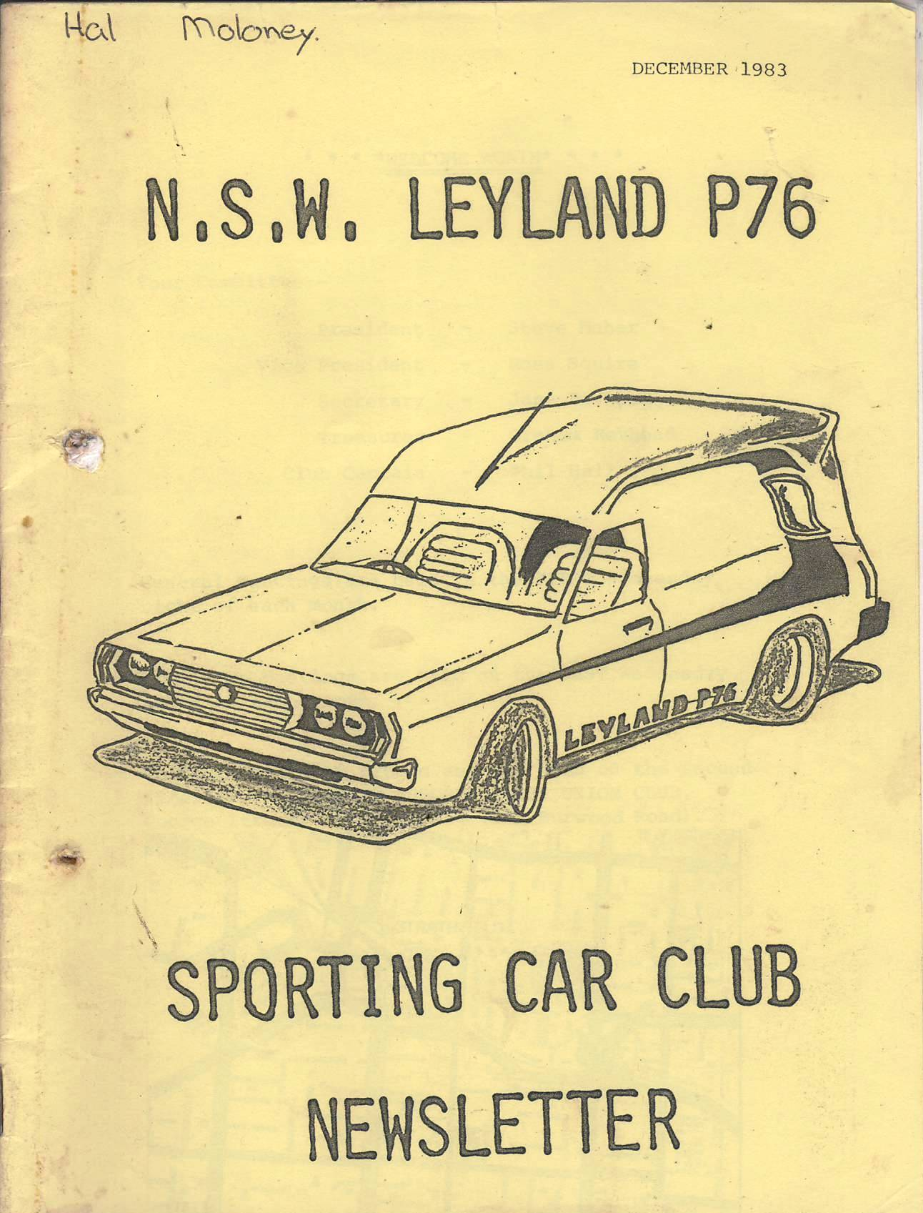 From the archives

