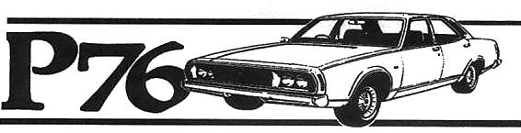
Hunter Valley P76 Owners Club
Associated with the NSW Country P76 club
November - December 2012 Newsletter
Hello all
Well Christmas is all but with us and the prospect of facing a new year.
From a P76 prospective clubs will have celebrations to mark 40 years of our beloved car.
New Zealand will start things off with celebrations on the North Island this year.
The Canberra club will have a function to remember the “Canberra Press Release”. The Canberra press release is one function that I have a lot of factory paperwork on so will dedicate the next magazine to publishing much of it.
At the time the P76 was launched I was working for Delore Motors in Newcastle and was able to grab their first demonstrator and take it for a run. I was astounded as to how easy this car slipped through corners especially for a big car. My first run was up the Newcastle hillcimb course.
My first P76 purchase did not occur until later when I went to work for Dennis Trigg who had the Leyland dealership in Toronto. More on that later.
There were several Leyland outlets in Newcastle area at the time of the P76 Launch and from memory they were:
New South Wales Motors: Newcastle
Delore Motors: Newcastle
Oster Motors: New Lambton
Triggs Motors: Toronto
Griffiths Garage: Belmont
Kime & Stephen: Raymond Terrace
George White Motors: Maitland
Sharpes Leyland: Cessnock
Garlands Garage: Stroud
Teasdales Leyland : Singleton

I wonder if Manus would like to write a bit of history on Teasdales.

.

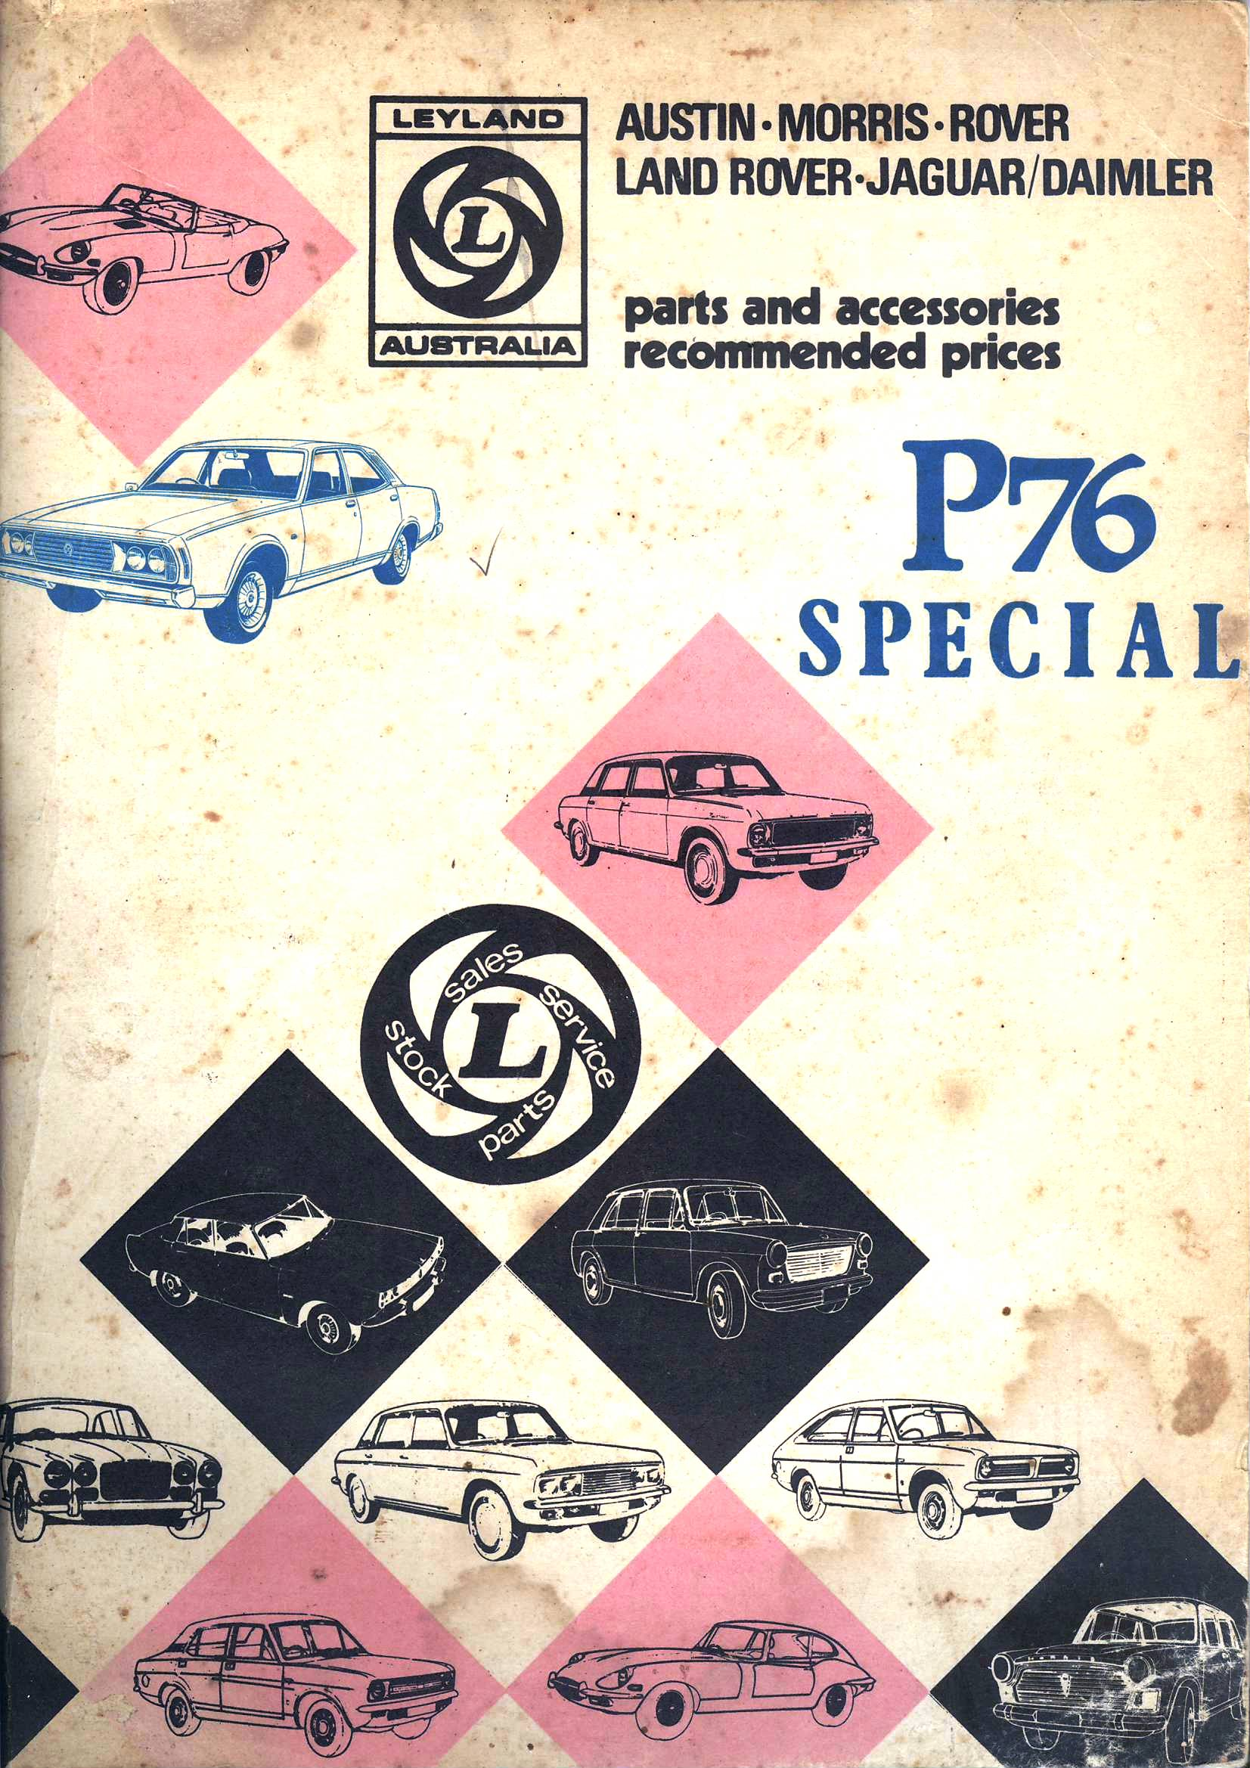

Front page of the first Parts list for P76

Coming Events:
There will be a club supplied Bar-B Que at My home on Friday 14th December where I will lay out many of my factory material that has been stored away for many years.
Any time from 5.00PM onwards, please advise if coming.
18 Irving St Beresfield.
Darren has arranged to meet up with the Sydney club in Lochinvar on Sunday 16th December.
Please contact Darren with numbers attending.

A combined meeting with the Country Club will have to be arranged possibly meeting at Parkes and visiting both the car and Elvis Presley museum at Parkes and the new car museum at Forbes 35km away. This is open for discussion of course.

The club in general:
As mentioned earlier clubs will be celebrating the 40th Anniversary of the P76 release so we must get together and discuss what we are doing in the Hunter to contribute.
A calendar of coming events for 2013 for our club would be a great benefit to allow us to make positive long distance plans. So send in your thoughts and ideas.
Spare Parts:
Darren has been putting some time into advising of spares and other things Leyland.
Darren has purchased a very interesting V8 Motor which is shown in this magazine.
I will be interested to hear from David Waters as to what it was used for.
Please let Darren know if you are after parts or if you have something to sell.
I have copied the front page of the first P76 parts price list that I received in 1973
Darrens engine:
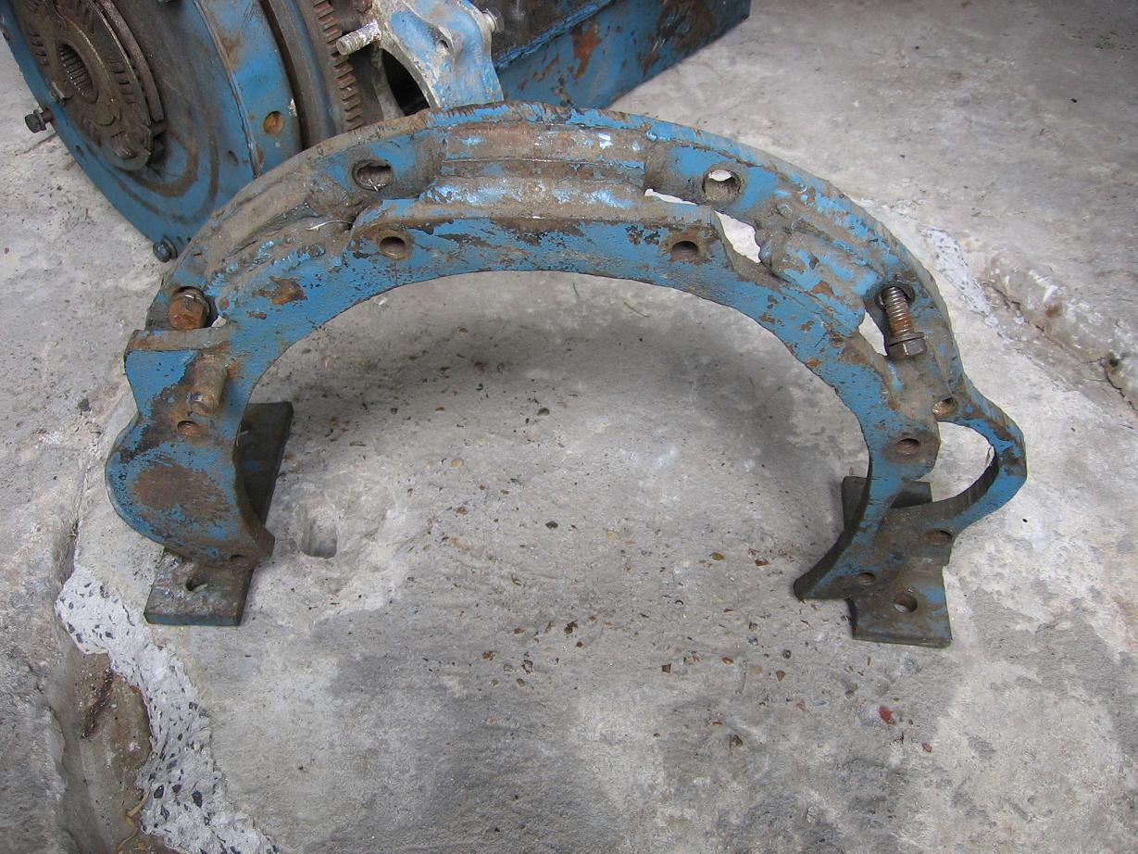

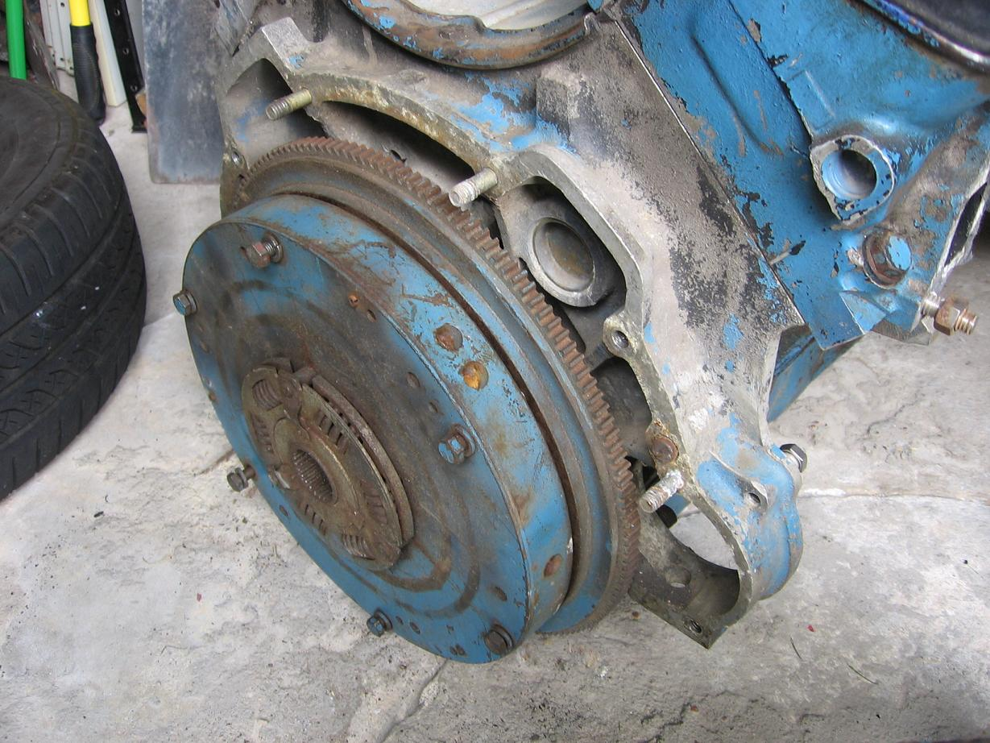

Gas is Good!
Calling all P-nuts!

I have owned a number of P76 V8’s over the years, and my best 2 have both been Duel Fuel, running almost entirely on LP Gas!

Not only is LP Gas a mere 69.9c per litre, apposed to Premium 95 at the moment, but it is a Higher Octane fuel at a minimum of 98 to 100 RON!

As we are aware, Leyland in their Infinite Wisdom, designed the V8 Engines to be LP Gas friendly, which allows you to run LP Gas without any conversion to the existing V8 Motor!

LP Gas also burns cleaner, maintaining your engine, which is always a good thing. In fact, I was very pleasantly surprised, when I recently changed my Spark Plugs.

I used to use the Leyland only occasionally for work and mainly for Club Runs, so did not change the Plugs as regularly as I usually do in all my cars. I left them in a longer. But this last 18 months I have been using the Leyland regularly, doing a 100K’s Daily, up to 600K’s a week!

Even though she has been running Perfectly, I thought I would change the plugs. As I knew they had been in for some time. When I checked my records I was shocked, these plugs had been in the car for 4 Years since 9th September 2008!

As a testament to LP Gas, the plugs I removed after over 4 years, were in Very Good Condition!!! See pic…

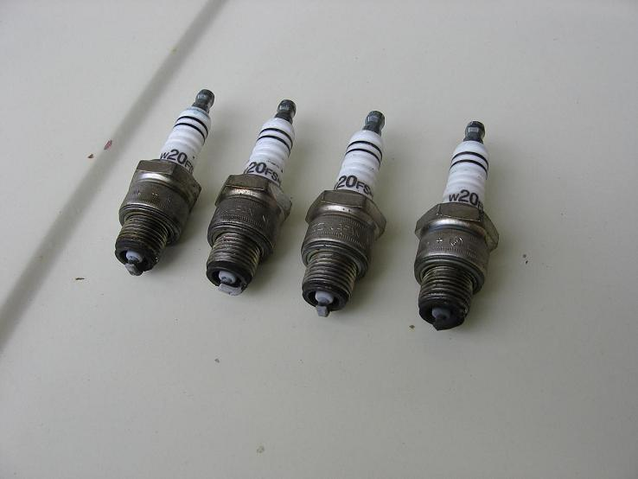

So, for those who are considering the Conversion. Go for

Leyland P76 Owners Club Hunter Valley
18 Irving St
Beresfield 2322 49 661 763 or halmoloney@gmail.com

Darren Holt - Parts
Email: leylandp76@westnet.com.au
Please check with Darren who can verify club membership

To finish I have shown a magazine cover from the NT P76 club that no longer operates

