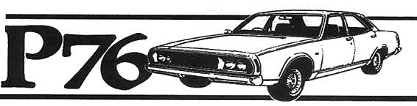
Hunter Valley P76 Owners Club
Associated with the NSW Country P76 club
May – June 2013 Newsletter
Editorial:
Hello all
Well I will start with the fantastic rollup for our club run to Gresford and will add some photos into the magazine. We invited the Historic Rally and the Singleton Classic car clubs to join us.
My son Denny and I are running the Targa Rally car in forest rallies again. We ran in a Rally Sprint at Awaba and finished second in class.
I am still looking at possibilities for our Hunter Club 40 year celebration, will have to advise
Hal
Club Fees:
Club memberships are due by the end of June Still a bargain at $25.00

Canberra 40th Anniversary function
Leyland P76 40 Years Anniversary will be held in Canberra over this weekend of June 29th & 30th. Any members requiring further information on Canberra please contact myself or see the P76 website for information

Our next club run will be on Sunday 4th of August
Start will be from McDonalds Thornton at 10.00 am and we will have Bar B Que lunch at Allworth. David Waters will give us a brief history on Allworth.
This will be bring your own for lunch. There is a gas Bar B Que there in the Park.
Please advise if attending
Any members with ideas on club functions. Get togethers Bar-B-Ques etc, please advise.

Other Car Club functions this year:
July 27th,Saturday Gloucester Show & Shine. $15.00 per car to help Haylee who is suffering with Nephrotic Syndrome.
We can make this a run day if there are any takers.
Sunday October 20th Spring Cruis-In Glendale to Hunter Valley gardens. This will be a club run for us
New P76 Book:
My P76 book is undergoing a complete revision and hopefully will be released by the end of this year with a lot of new information and photos. More information on this later.

The club in general:
As mentioned earlier clubs will be celebrating the 40th Anniversary of the P76 release so we must get together and discuss what we are doing in the Hunter to contribute.
A calendar of coming events for 2013 for our club would be a great benefit to allow us to make positive long distance plans. So send in your thoughts and ideas.
Will discuss these at Allworth.

Photos from last club run.
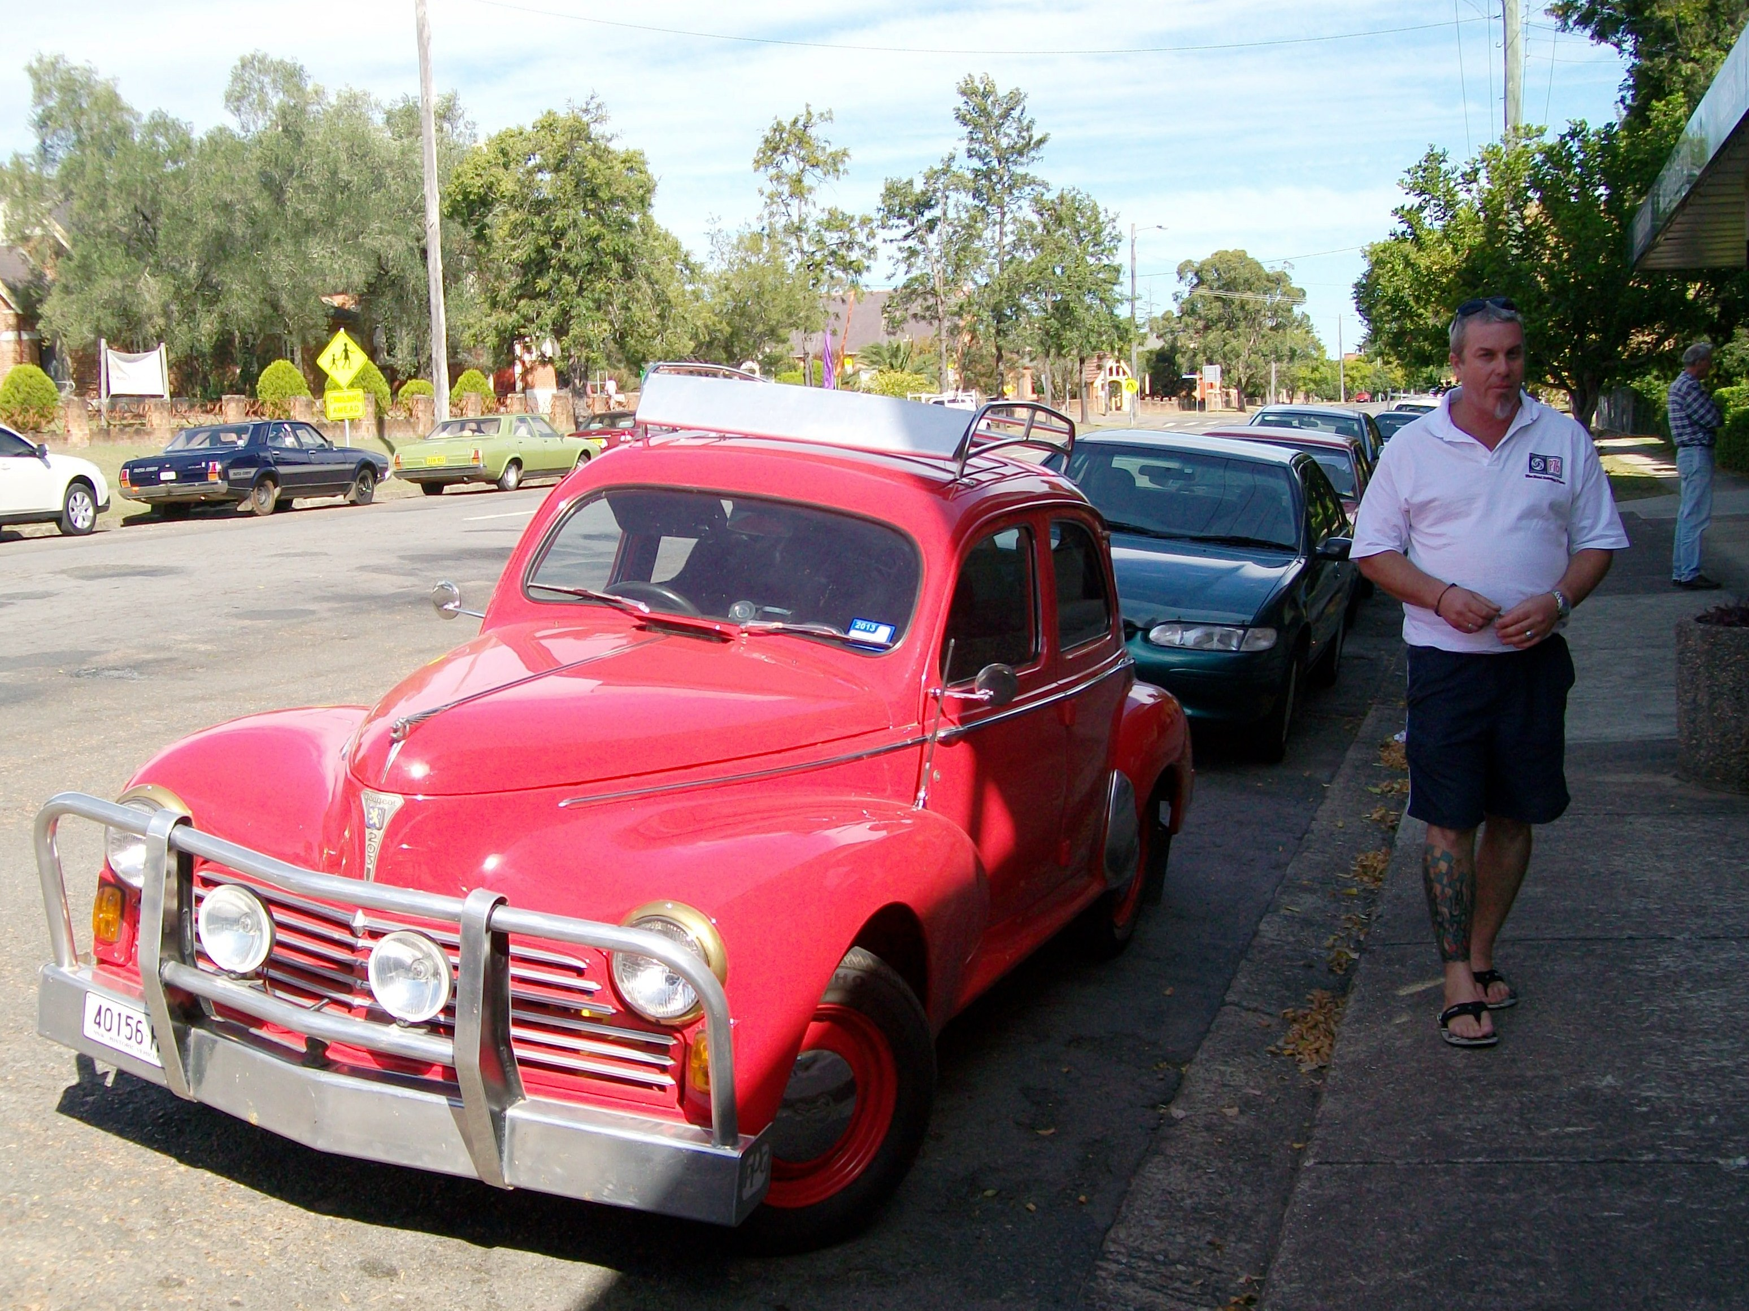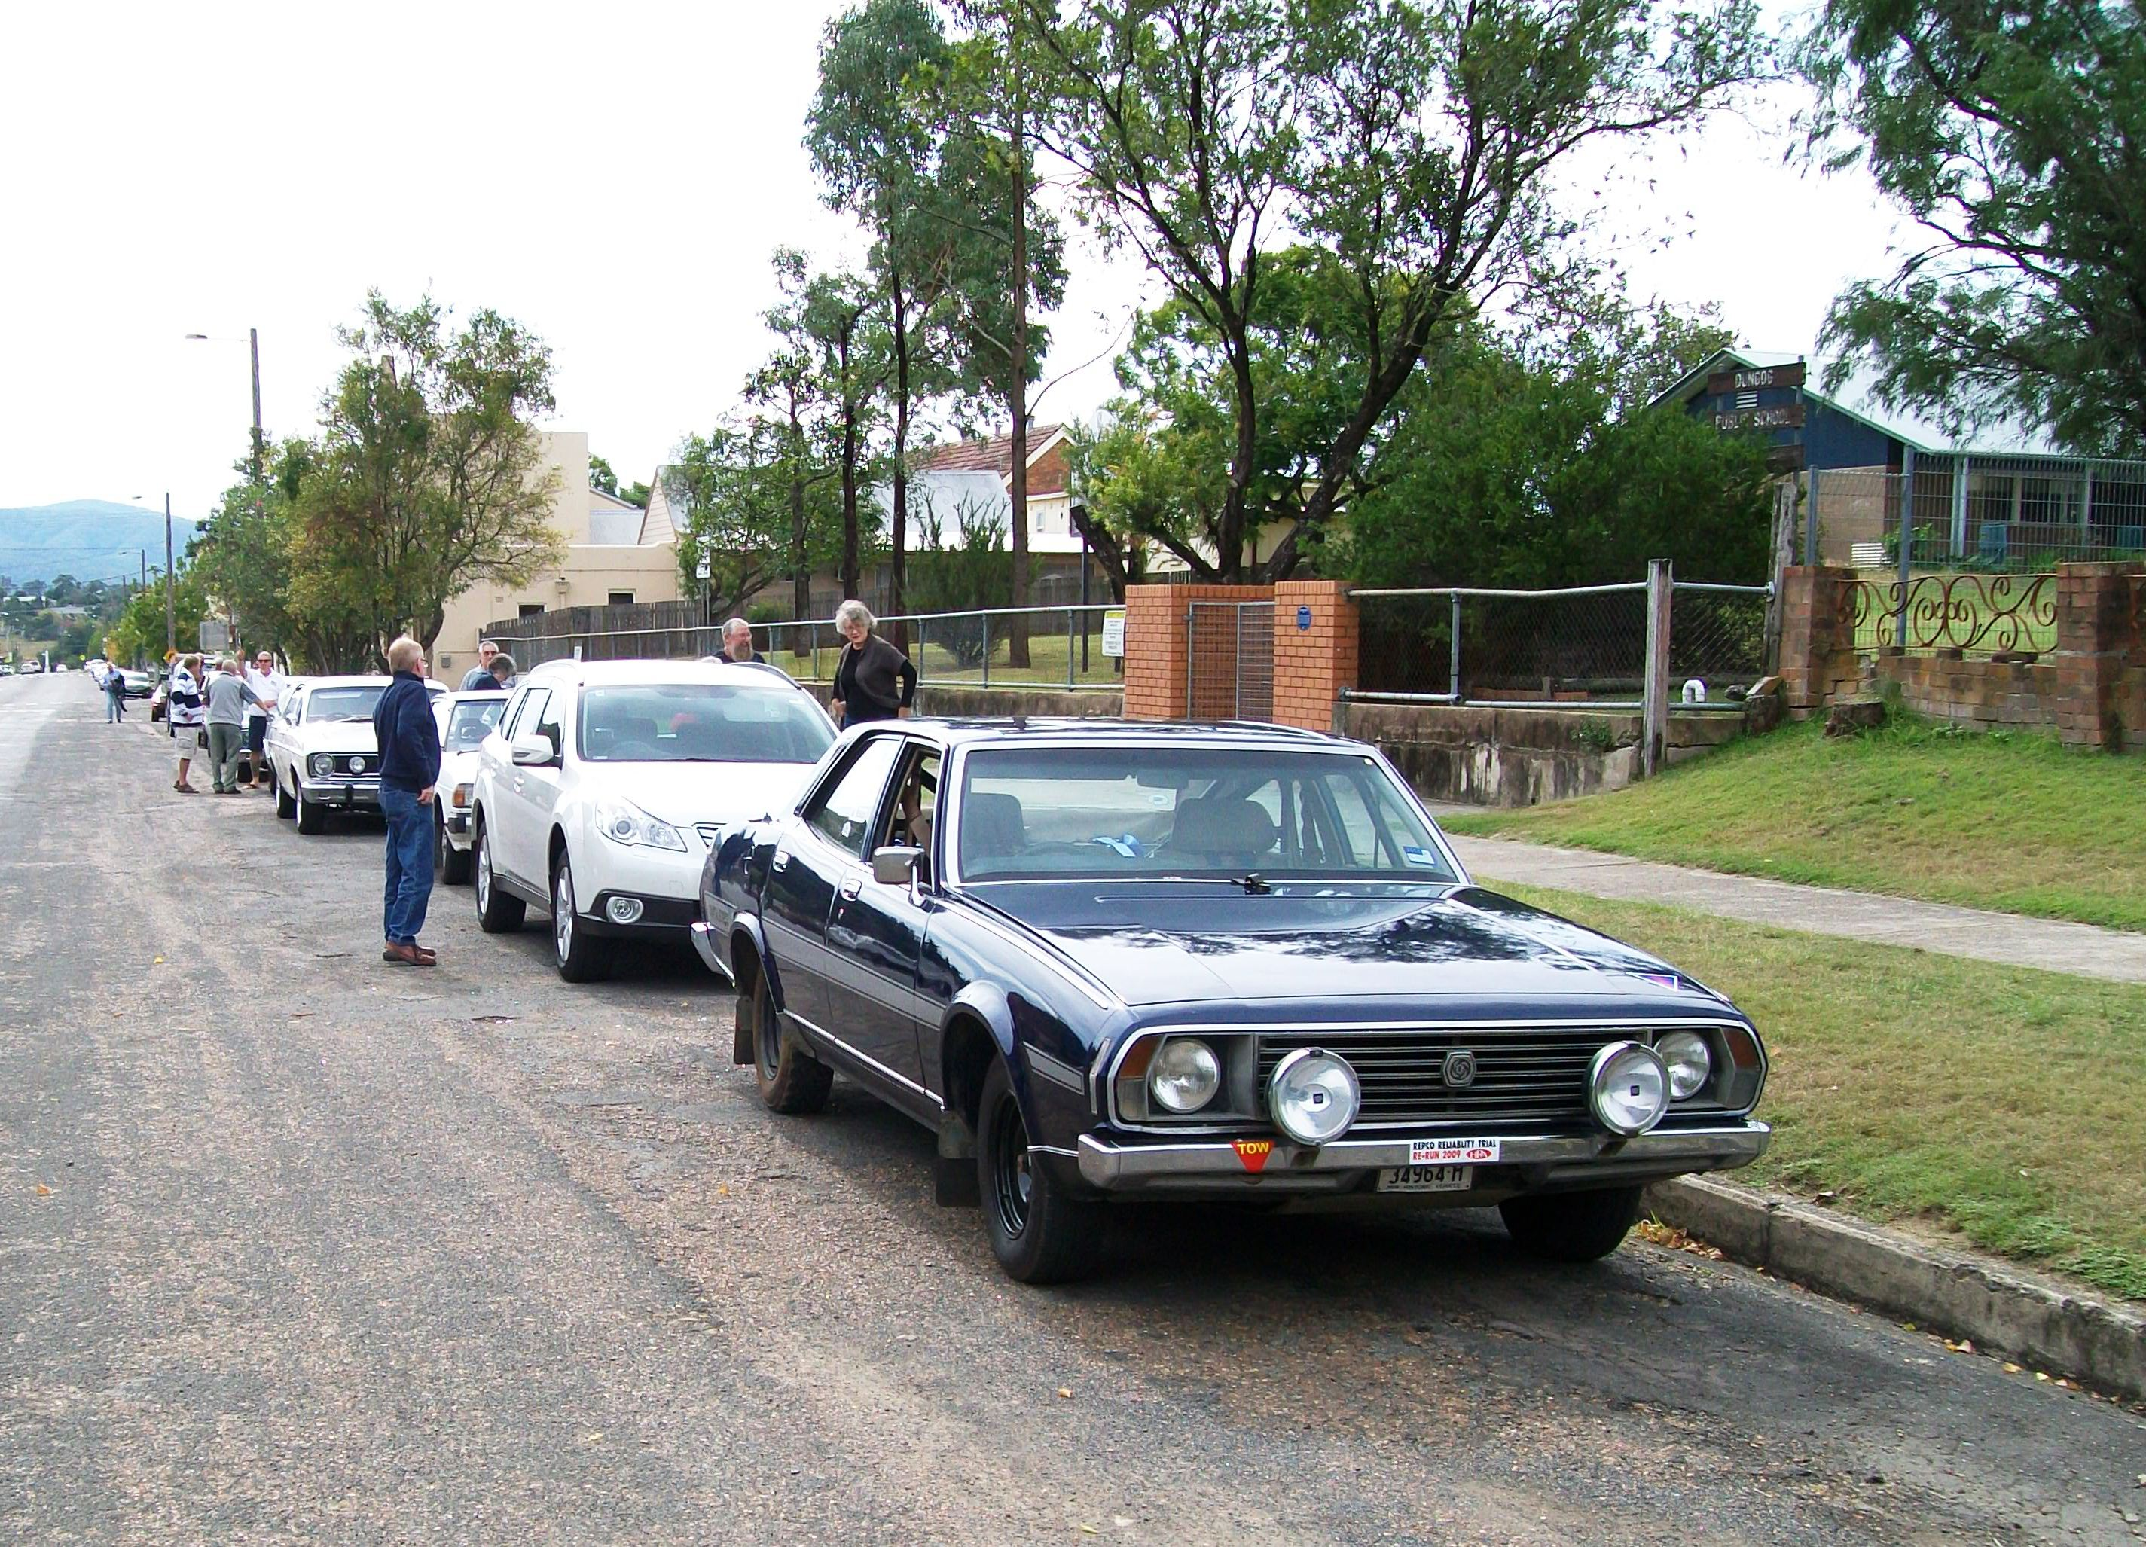
1.Craig Anderson with John Brumbys Peugeot and our P76 cars in the background.
2. Hals P76, the Andrews new Subaru & members from the Singleton Classic club.

Spare Parts:
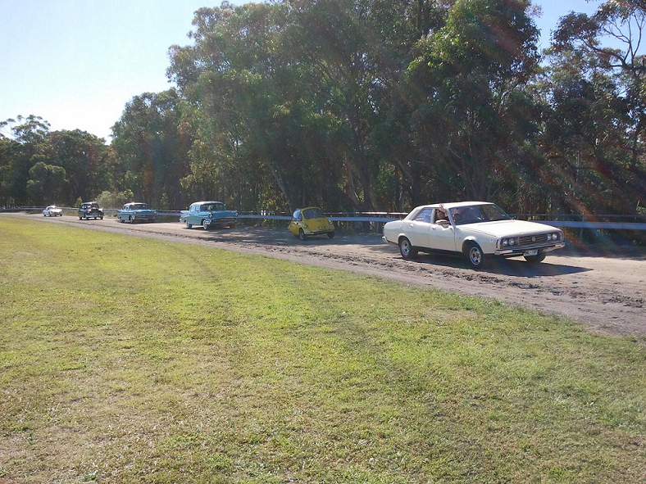
Photo is Darren Holt leading the Parade at the Morisset Festival in his Country Cream P76.
The Trojan car behind is interesting but is not a Leyland Trojan.
We were not invited this year and again I noticed that for some strange reason there were Five large car shows in the Hunter on the same day. I do not know why they can’t be separated.
Thanks Darren for carrying the Leyland flag.

Darren did send other pages for inclusion but I was unable to download them.

I will add a short story on the Leyland Trojan next Magazine

P76 Stamps:
I picked up my first P76 stamps and envelopes from Australia Post yesterday as I had put in a special request for an early delivery.
Check your local Post Office if you would like to purchase some as each Post Office will not be receiving many.

Leyland P76 Owners Club Hunter Valley
18 Irving St
Beresfield 2322 49 661 763 or halmoloney@gmail.com

Darren Holt - Parts
Darrenpnut76@yahoo.com.au

