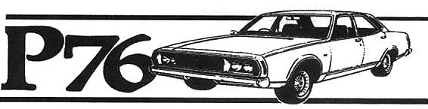
Leyland P76 Owners Club Hunter Valley
May - June 2012 Newsletter
The club seem to have started off on the right foot with new members meeting each other and exchanging information. It is interesting to see P76 cars that have not been seen before in our area.
Some of the new members are Matt Farrow (Must catch up Matt) & Brian Andrews from Singleton who is restoring a super along with the members that attended the first get together. I will publish a full member list next newsletter
We will also commence member profiles next newsletter.
Crown – Bryson P76
I have listed the New Zealand & Australian history of the Crown – Bryson P76 that is in America at the moment competing in a month long Rally.
Go to TransamericaP76 on Google for all the photos and updates
The P76 is a NZ built original car ex Phillip Meyer. Roll cage by Possum Bourne Motorsport.
Fully seam welded body. Car shipped to Aust and fitted with P76 V8 bored and
sleeved to 5.0ltr, steel crankcase girdle, Manley alloy rods, Mercedes Benz
forged alloy pistons, balanced etc. All machining done by Graham Wilkins. Engine
assembled by Trevor Seaman (Trevs Trumps). Rover 3.9 inlet manifold and fuel
injection with coil pack ignition through stock dizzy with modified Commodore
electronic ignition. Compression only 9.5:1 so it can run on US pump gas. Custom
extractors with twin crossover exhaust. Haltech computer and dash. Dyno tuned by
Stewart Wilkins of SSS Automotive. Alloy radiator. Murray Coote suspension. 4
wheel disc brakes with Falcon 3.45 BW rear end. T5 gearbox. Race fuel cell in
boot. Fibreglass bonnet and boot. Could not stop wheelspin in dyno so exact
figures not available but is in excess of 300hp and over 400 ftlbs torque.
Engine is way over engineered for a 5500rpm limit but can be punished all day,
every day from one side of America to the other.
Targa Tasmania Well I finally won a Targa Plate in Tasmanias’s Targa Rally along with a class & Category win. I was navigating for Col Bray in an Ex Works Falcon XR6. My Leyland P76 will be used in a major event very soon, stay tuned.
New Leyland book: The book is $40.00 + Post for Car club
members Contact Roger Foy 0n 9449 1524 or rogerfoy1@bigpond.com
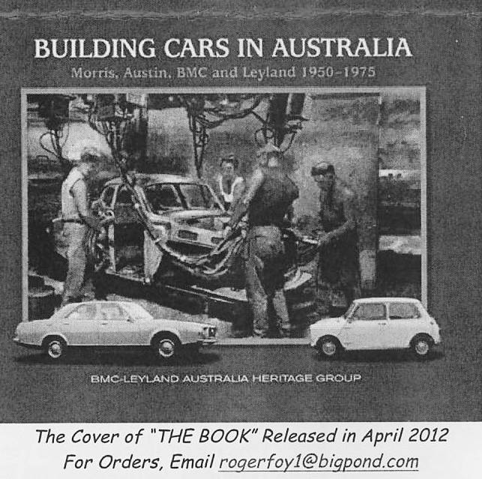
Coming Events:
May 20th Sunday Morisset Fair Contact Alissa Holt at gillygirl2018@yahoo.com.au Or just turn up.
June 1st Saturday Midday our second get together at Waters Park in Allworth. Travel North on the Pacific Highway then take the Buckets Way towards Booral then turn right towards Allworth. The park is on the right as you enter town. Bring your own tucker.
Contact myself or David Waters on 49 949 196 for directions.
That other P76
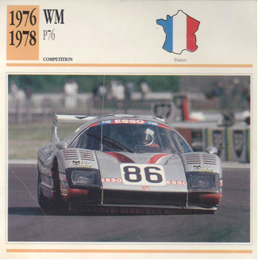
Leyland P76 Owners Club Hunter Valley
18 Irving St
Beresfield 2322 49 661 763 or halmoloney@gmail.com

