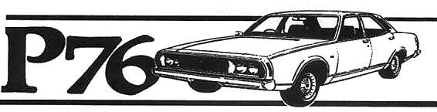
Hunter Valley P76 Owners Club
Associated with the NSW Country P76 club
January – April 2014 Newsletter
Editorial:
Hello all
There have been some changes since the last Newsletter
Our magazine will now be produced Quarterly as printing costs are eating into our resources and finding sufficient information to post is a problem.

Canberra 40th Anniversary of the P76 function: (Repeat article)
While I did not attend I believe the occasion was a success. One of our members, John Judd, had his car on the cover of the Leyland Heritage magazine following the Canberra event, well done John.

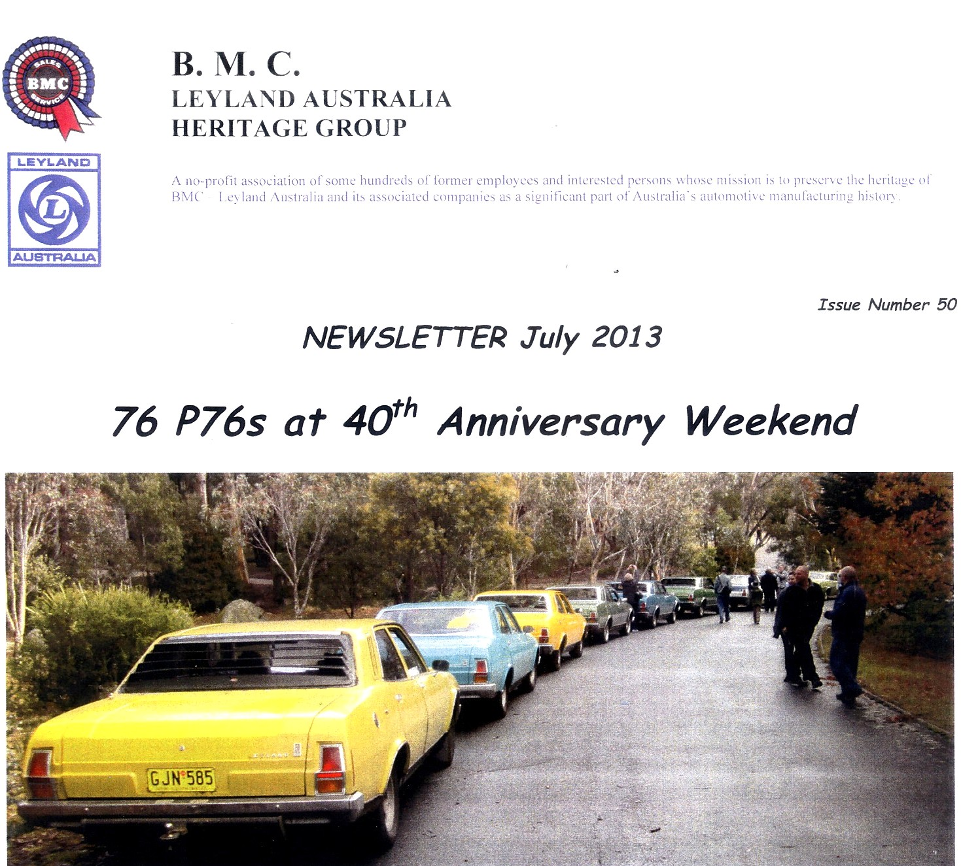

Coming Events:
Combined run with the Rolls Royce Car Club at the Hunter Valley Gardens on Saturday May 10th.
I will phone all with directions and we will meet in the car park of the Pokolbin Village Shops at 8.30am. Hope this early start is ok as the RR club are starting their run at 9.00am. We will be issued with free Vouchers to spend.

Sentimental Journeys;
This will be a club run to Singleton commencing in the Beresfield baths car park at 7.00am following John Renshaw drive and joining the Hunter Freeway at Kurri Kurri to continue to Singleton.

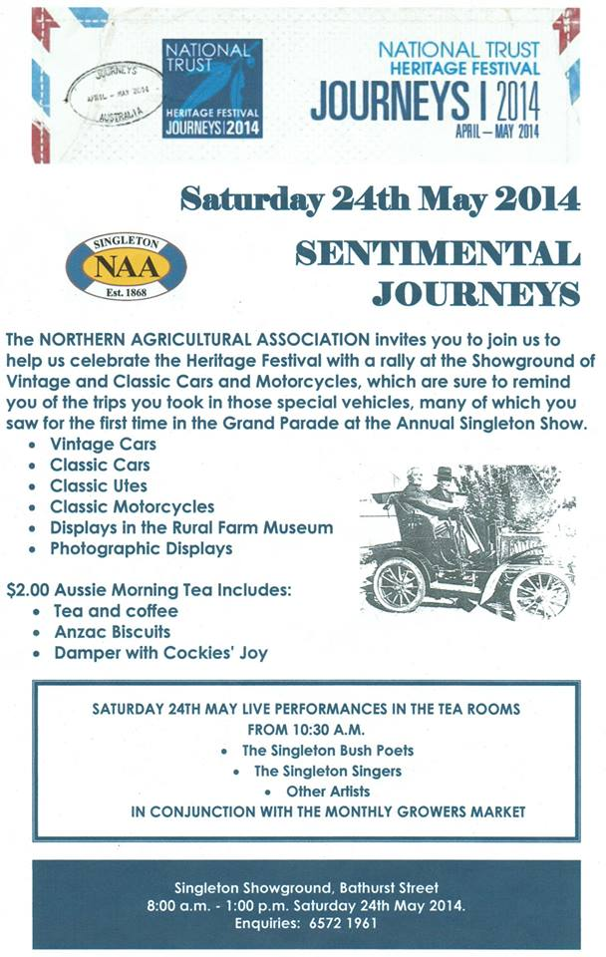

Targa 40th Party:
, our Targa Party is still on July 26th. With the opening of the Hunter expressway it will be easiest to meet at the Lost in the 50’s car museum to start the day off.
Coming from Singleton turn right at the first set of traffic lights at Cameron Park then take the next turn right into Farragher Way and take the next right at the T and the museum is on your left. Time 10.00am cost $15.00
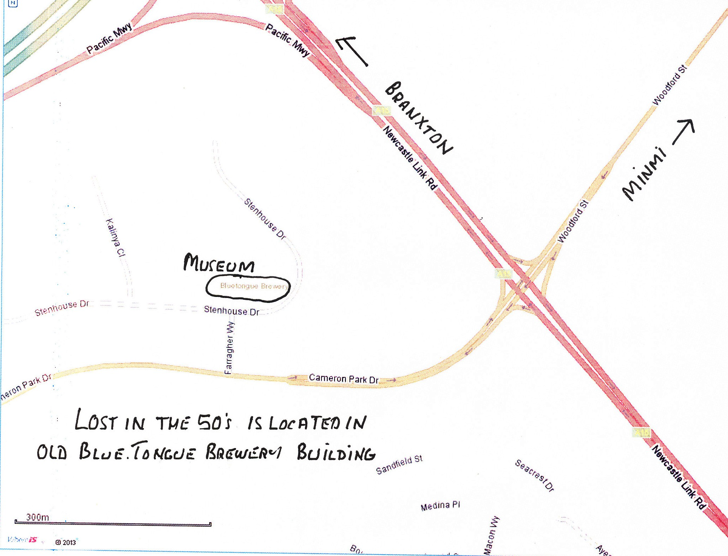

Window Moulds:
I am currently sorting out the 200 + chrome P76 moulds that I have and two things have stood out
The RH & LH vertical rear windscreen moulds have the same part number HYC5674-5 but the parts book list them as RH HYC5674 & the LH as HYC5675
The vertical rear window moulds are two different lengths which may explain why I have had considerable trouble with the green car having one that is too short.
Most that I have are 407mm long and others are 426mm long

The combined Car Club run January 19th 2014:
The run from Croudace Bay Park was an enjoyable day with two P76 cars attending along with 15 from the Historic Rally Club.
The 140km run was down around the Central Coast and event took in a place that I had not been to before.

Display at Bunnings Singleton:
We also displayed our cars at Bunnings Singleton on a very wet night which was unfortunate as Bunnings went to great lengths to put on a good show. The display was combined with the Singleton Classic Car Club. Bunnings moved our cars indoors as the rain did not let up. The three Leylands displayed were Brian and Manus Andrews and also our Targa Rally car along with Round Australia Trial photos..
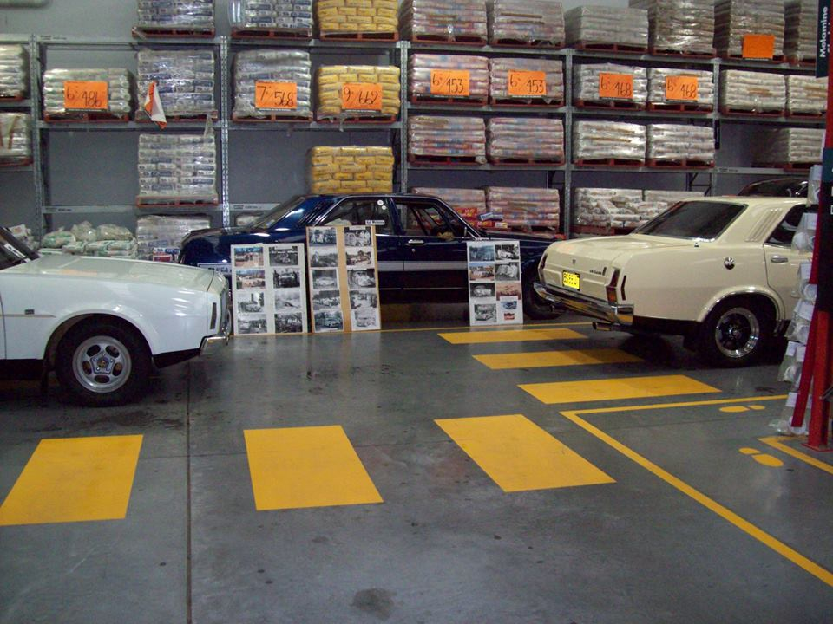

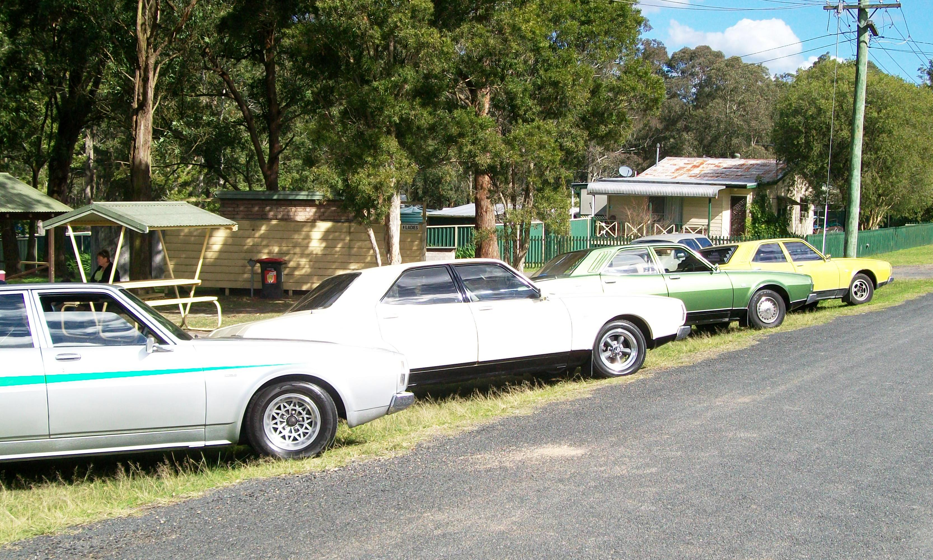
Club cars at Allworth

Our member Gordon Murray is now out of hospital and improving. We hope to see Gordon and Kay at a Club run soon.
Our member Craig asked me if I had any information on the Shaw P76. I have managed to uncover a sales receipt and the service book.
The car was taken into stock at New South Wales Motors in July 1973 and was held in stock until sold on 24th October 1974. If this P76 was not owned outright by NSW Motors then the floor plan interest would have more than eaten up any profit from a sale.
The P76 in question was an Column Automatic V8 Deluxe surely an easy target for the cab industry.

